Join Us In Supporting Our Athletes

Since 2004, the Westlake Athletic Club (WAC) has provided supplemental financial support to our Modified, Junior Varsity and Varsity sports teams

Now, more than ever, our sports teams face challenges and unforeseen expenses and need our help

Become a Westlake Athletic Club member for the 2022-2023 school year to support our current and future student athletes

Member Info (please complete)

Name: __________________________________
Street: _________________________________
City/Zip: _______________________________
Student(s) Name/Grade: ___________________
________________________________________

Phone: _________________________________
Email: __________________________________
Sport(s): __________________________
Level: ☐ Gold ($100) ☐ Silver ($75) ☐ Family ($50)

Donation Options

- Mail-in completed membership form with check payable to Westlake Athletic Club to:
  - Westlake Athletic Club, P.O. Box 332 Hawthorne, NY 10532
- Mail-in completed membership form (see address above) and donate using either:
  - PayPal –directly to westlakeathleticclub1@gmail.com or scan this QR code:

  - CheddarUp – make donation at: https://yearly-membership-to-the-westlake-athletic-club.cheddarup.com/

- Complete online form and Paypal donation on: https://www.westlakeathleticclub.org/

(Donations are tax deductible)

Together, we can do so much more

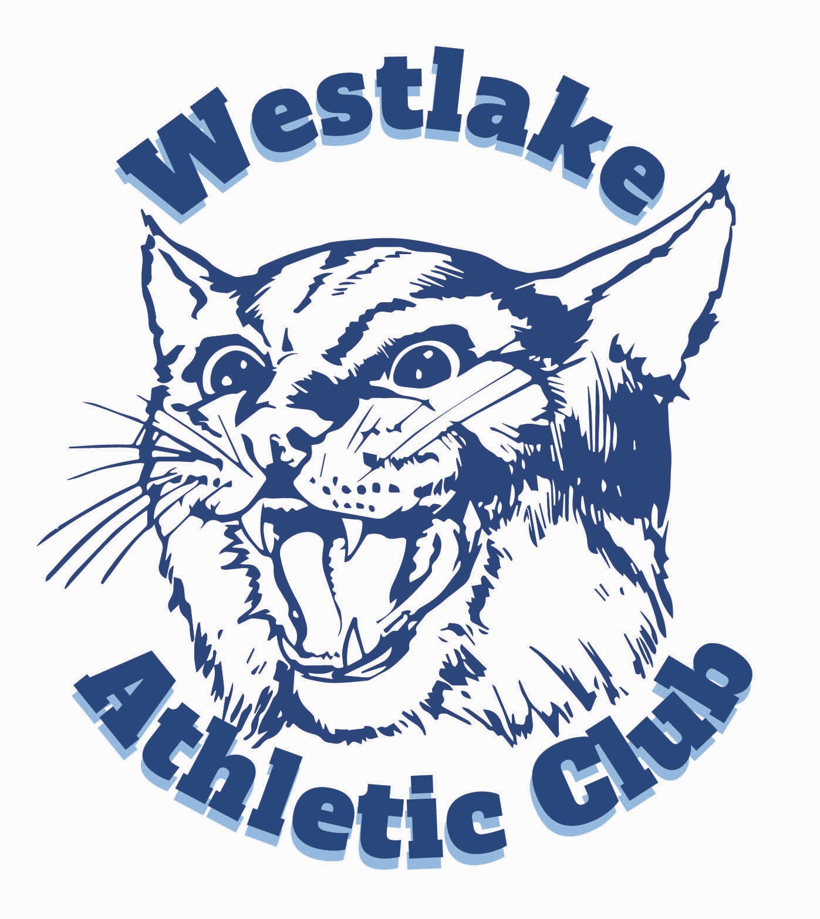
The Westlake Athletic Club (WAC) is a community based, all volunteer, 501c organization founded in 2004. We raise funds for our Modified, JV and Varsity sports teams via memberships, fundraising events & donations.

For more information, including a list of recent accomplishments and volunteering opportunities, please visit: http://www.westlakeathleticclub.org/

